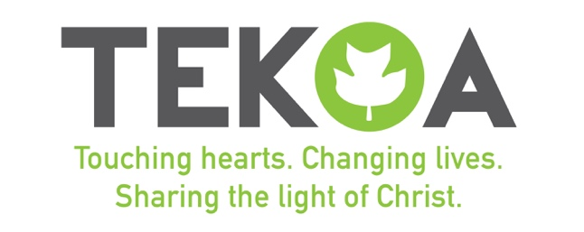
United Methodist Camp Tekoa
PO Box 1793
Flat Rock, NC, 28731
Phone: 828-692-6516
Email: jisley@camptekoa.org

RELEASE OF LIABILITY/LIABILITY WAIVER FORM
To be completed by all regardless of the level of participation - one form per person.
Full Legal Name of Participant: _________________________________________________________________________
Full Address: ________________________________________________________________________________________
Email: ______________________________________________________________________________________________
PRINT Full Name of Emergency Contact: _________________________________________
Relationship of Emergency Contact: _____________________________________________
Emergency Contact Phone: ____________________________ Second Phone: (optional) ____________________
Name of Event __________________________________________________ Date of Event: _____________________
Agreement to Participate I understand the program goals and agree to participate in the programs and activities to the best of my ability. I agree and hereby state that I am aware and understand that all of the activities are strictly voluntary and it is my own choice to participate in each activity to whatever degree I deem appropriate and after due consideration of my own physical health, physical abilities and medical conditions. I have informed the Director of Camp Tekoa and/or the leader of the event of any medical conditions I may have. I further state that in choosing to participate I am not under the influence of any chemical substance including alcohol.
Medical and Liability Release I willingly and knowingly assume for myself, my heirs, family members, executors, administrations and assigns all risk of physical injury and sickness and emotional upset which may occur during or after participating in any aspect of this event and hereby agree to hold Camp Tekoa its employees, instructors, facilitators, Board members and agents harmless for any liability arising out of my participation in the event. I hereby give permission to the Camp Tekoa parties and to contact emergency services for help, whether or not the Camp Tekoa parties have contacted my emergency contact, and give my permission to a licensed physician or other licensed medical provider to provide proper treatment, including but not limited to hospitalization, injection, anesthesia and/or surgery. I hereby RELEASE, WAIVE AND FOREVER DISCHARGE Camp Tekoa from any and all claims, liabilities , causes of action, damages demands, judgments, executions, liens and costs whatsoever in law or equity, including, without limitation, liability for death or bodily injuries to any person or damage to any property resulting from any (1) claims made against medical providers of emergency services under this authorization, or (2) against the Camp Tekoa Parties for obtaining emergency medical series for me pursuant to this authorization and waiver.
Media Release I hereby grant and convey to the Camp Tekoa Parties all right, title and interest I may have in any and all photographs, motion pictures, video recordings, and any other recordings made during or about the event, and the Camp Tekoa parties shall have the right to exploit such recordings throughout the universe, an unlimited number of times, in perpetuity by any and all means and media, now known or hereafter invented.
I have read all information regarding the event at Camp Tekoa, including policies, procedures, limitations, and possibilities. Any exceptions to participating in the event are designated below:

Your Printed Name Signature Date

Your Parent’s or Guardian’s Signature Date
*If you are under the age of 18, your parent or guardian must execute this form on your behalf.

___________________________________________________________________________________________

